7. Scenario: You are working as a data analyst for an e-commerce company. You have been given

a dataset containing information about customer orders, stored in a Pandas DataFrame named

order_data. The DataFrame has columns for customer ID, order date, product name, and order

quantity. Your task is to analyze the data and answer specific questions about the orders.

Question: Using Pandas DataFrame operations, how would you find the following information

from the order_data DataFrame:

1. The total number of orders made by each customer.

2. The average order quantity for each product.

3. The earliest and latest order dates in the dataset.

CODE:

import pandas as pd

order_data = pd.read_csv(r'C:\Users\hp\Desktop\order_data.csv', parse_dates=["Order_Date"])

orders_per_customer = order_data['Customer_ID'].value_counts().sort_index()

print("1. Total number of orders by each customer:")

print(orders_per_customer)

average_quantity_per_product = order_data.groupby('Product_Name')['Order_Quantity'].mean()

print("\n2. Average order quantity for each product:")

print(average_quantity_per_product)

earliest_order = order_data['Order_Date'].min()

latest_order = order_data['Order_Date'].max()

print(f"\n3. Earliest order date: {earliest_order}")

print(f" Latest order date: {latest_order}")

OUTPUT:

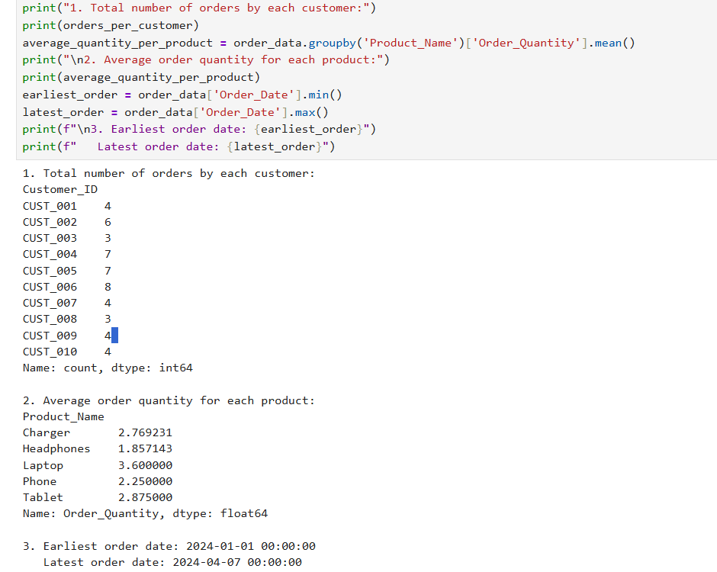

DATASET:

|  |  |  |  |
| --- | --- | --- | --- |
| Customer_ID | Order_Date | Product_Name | Order_Quantity |
| CUST_006 | ######## | Tablet | 1 |
| CUST_006 | ######## | Phone | 1 |
| CUST_010 | ######## | Charger | 1 |
| CUST_005 | ######## | Charger | 2 |
| CUST_001 | ######## | Laptop | 1 |
| CUST_008 | ######## | Charger | 1 |
| CUST_009 | ######## | Tablet | 3 |
| CUST_002 | ######## | Headphones | 1 |
| CUST_007 | ######## | Laptop | 5 |
| CUST_002 | ######## | Laptop | 2 |
| CUST_009 | ######## | Tablet | 3 |
| CUST_005 | ######## | Tablet | 4 |
| CUST_010 | ######## | Phone | 2 |
| CUST_006 | ######## | Laptop | 5 |
| CUST_010 | ######## | Phone | 2 |
| CUST_004 | ######## | Charger | 5 |
| CUST_002 | ######## | Laptop | 5 |
| CUST_001 | ######## | Laptop | 4 |
| CUST_004 | ######## | Headphones | 2 |
| CUST_005 | ######## | Laptop | 4 |
| CUST_002 | ######## | Charger | 4 |
| CUST_004 | ######## | Phone | 2 |
| CUST_002 | ######## | Phone | 1 |
| CUST_007 | ######## | Headphones | 1 |
| CUST_005 | ######## | Charger | 4 |
| CUST_008 | ######## | Phone | 3 |
| CUST_006 | ######## | Tablet | 4 |
| CUST_003 | ######## | Charger | 4 |
| CUST_006 | ######## | Charger | 4 |
| CUST_006 | ######## | Headphones | 1 |
| CUST_004 | ######## | Phone | 1 |
| CUST_005 | ######## | Charger | 1 |
| CUST_002 | ######## | Phone | 4 |
| CUST_010 | ######## | Tablet | 3 |
| CUST_003 | ######## | Headphones | 1 |
| CUST_009 | ######## | Tablet | 2 |
| CUST_004 | ######## | Headphones | 2 |
| CUST_003 | ######## | Charger | 2 |
| CUST_008 | ######## | Headphones | 5 |
| CUST_007 | ######## | Laptop | 4 |
| CUST_005 | ######## | Phone | 2 |
| CUST_009 | ######## | Phone | 4 |
| CUST_004 | ######## | Laptop | 2 |
| CUST_006 | ######## | Tablet | 3 |
| CUST_001 | ######## | Laptop | 4 |
| CUST_004 | ######## | Charger | 2 |
| CUST_001 | ######## | Charger | 1 |
| CUST_006 | ######## | Phone | 4 |
| CUST_007 | ######## | Charger | 5 |
| CUST_005 | ######## | Phone | 1 |
|  |  |  |  |
|  |  |  |  |